

Product Dissection for Swiggy

Company Overview:
Swiggy is a public company based in Bengaluru (India), founded in 2014 by Nandan Reddy, Phani Kishan Addepalli, Sriharsha Majety and Rahul Jaimini. It operates as a Platform offering food and grocery delivery, dine-out bookings, and access to restaurant deals. Swiggy is one of India’s leading on-demand convenience platforms that connects users with restaurants, delivery partners, and local stores.

Core Features of Swiggy:

Restaurant Discovery & Search
Users can search for restaurants by name, cuisine, location, or ratings, making it easy to find food that matches their preferences.
Digital Menu & Customization
Swiggy provides detailed digital menus with prices, images, and customization options such as add-ons or spice levels.
Real-Time Order Tracking
Customers can track their order live from preparation to delivery, including the delivery partner’s location and estimated delivery time.
Multiple Payment Options
Supports UPI, credit/debit cards, wallets, net banking, and cash on delivery for user convenience.
Swiggy Delivery Network
Swiggy manages its own delivery partners, ensuring fast and reliable delivery even for restaurants without in-house delivery.
Ratings & Reviews System
Users can rate restaurants and delivery partners, helping maintain quality and guiding other customers.
Offers, Discounts & Subscriptions
Features like promo codes and Swiggy One subscription provide discounts, free deliveries, and exclusive benefits.
Order History & Reordering
Users can view past orders and quickly reorder their favorite meals.
Notifications & Alerts
Real-time notifications keep users updated about order status, offers, and delivery progress.
Customer Support
In-app support helps users resolve issues related to orders, payments, or deliveries quickly.

Product Dissection and Real-World Problems Solved by Swiggy:

Swiggy is an online food delivery platform that connects customers, restaurants, and delivery partners through a single digital ecosystem. From a product dissection perspective, Swiggy consists of a customer app for browsing restaurants, placing orders, making payments, and tracking deliveries; a restaurant partner app for managing menus, accepting orders, and updating preparation status; a delivery partner app for order pickup, navigation, and delivery; and a strong backend system that handles order matching, payments, real-time tracking, notifications, and recommendations.
By integrating these components, Swiggy solves several real-world problems such as the difficulty of ordering food from multiple restaurants, lack of reliable home delivery, uncertainty about delivery time, and inconvenience of cash-only payments. It enables customers to easily discover restaurants using ratings and reviews, helps small restaurants gain visibility and increase sales, ensures timely and trackable deliveries through its logistics network, and creates flexible employment opportunities for delivery partners.
Overall, Swiggy uses technology to simplify food ordering, improve customer convenience, and build an efficient on-demand food delivery ecosystem.

Case Study: Real-World Problems and Swiggy’s Solution

Problem 1: Lack of Convenient Food Access

Challenge: In many urban and semi-urban areas, users often struggle to access a wide variety of restaurants from a single place. Visiting multiple restaurant websites or physically traveling to order food is time-consuming and inefficient. This lack of convenience limits food choices and reduces overall user satisfaction.
Swiggy’s Solution:
Swiggy solves this problem by aggregating thousands of restaurants onto one unified digital platform. Users can easily browse restaurant menus, compare prices, check availability, and place orders instantly. This centralized ecosystem significantly reduces effort, saves time, and provides users with diverse food options at their fingertips.

Problem 2: Unreliable & Slow Food Delivery

Challenge: Traditional food delivery systems often suffer from delays, poor coordination, and lack of transparency. Customers are left uncertain about delivery timelines, leading to frustration and loss of trust in delivery services.
Swiggy’s Solution:
Swiggy has built a robust and optimized delivery partner network supported by real-time GPS tracking. Users can monitor their order status from preparation to doorstep delivery, ensuring transparency. Smart route optimization and efficient partner allocation help reduce delivery time and improve reliability, creating a seamless user experience.

Problem 3: Discovery of New Restaurants

Challenge: Many users find it challenging to discover high-quality or new restaurants that match their preferences. Without reliable information, users often stick to familiar choices, missing out on better or more affordable options nearby.
Swiggy’s Solution:
Swiggy enhances restaurant discovery using advanced search filters, customer ratings, reviews, and cuisine-based categorization. Personalized recommendations powered by AI analyse past orders and preferences to suggest relevant restaurants. This data-driven discovery system helps users confidently explore new food options.

Problem 4: Need for Daily Essentials on Demand

Challenge: Modern lifestyles often lead to last-minute needs for groceries and daily essentials. Traditional grocery shopping can be inconvenient during emergencies or time constraints.
Swiggy’s Solution:
Swiggy Instamart addresses this challenge by offering ultra-fast delivery of groceries and essentials within minutes. By operating hyperlocal warehouses and optimizing inventory management, Instamart fulfills urgent customer needs efficiently, extending Swiggy’s value beyond food delivery.

Conclusion

Swiggy effectively addresses multiple real-world problems related to food access, delivery reliability, restaurant discovery, and on-demand essentials. By leveraging technology, data, and a strong hyperlocal network, Swiggy provides a convenient, fast, and user-friendly experience. Its solutions not only save time and effort for users but also improve service reliability and choice. Overall, Swiggy’s product design demonstrates how a customer-centric and technology-driven approach can successfully solve everyday consumer challenges.

Swiggy’s User-Centric Approach

Swiggy uses a hyperlocal and data-driven approach to improve user experience and delivery efficiency. It shows nearby restaurants using location data, which helps in faster deliveries.
AI analyses user order history and preferences to provide personalized food recommendations. Swiggy also predicts high-demand periods and manages delivery partners efficiently. Dynamic pricing helps balance demand and supply, ensuring timely deliveries.

Schema Design Based on Top Features
The database schema for Swiggy is designed to efficiently manage users, restaurants, menu, orders, delivery partner, payments and review. Each entity represents a core component of the platform and is connected through primary and foreign keys to maintain data integrity and smooth operations.

Key Entities & Attributes:

User Entity:
- UserID (Primary Key): A unique identifier for each user.
- Name: The user’s full name.
- Email: The user’s email address for communication and login.
- Phone Number: Contact number used for order updates and verification.
- Address: Delivery address of the user.
- Registration Date: The date when the user registered on Swiggy.

Restaurant Entity:

RestaurantID (Primary Key): A unique identifier for each restaurant.

Name: The name of the restaurant.

Location: The physical location of the restaurant.

Cuisine Type: Type of food offered (e.g., Indian, Chinese).

Rating: Average user rating of the restaurant.

Is Open: Indicates whether the restaurant is currently open.

Menu Entity:

MenuID (Primary Key): A unique identifier for each menu item.

RestaurantID (Foreign Key): Links the menu item to a restaurant.

Item Name: Name of the food item.

Price: Cost of the food item.

Availability: Indicates whether the item is available or not.

Order Entity:

OrderID (Primary Key): A unique identifier for each order.

UserID (Foreign Key): The user who placed the order.

RestaurantID (Foreign Key): The restaurant from which the order is placed.

Order Time: Date and time when the order was placed.

Order Status: Current status of the order (Placed, Preparing, Delivered).

Total Amount: Total cost of the order.

Delivery Partner Entity:

PartnerID (Primary Key): A unique identifier for each delivery partner.

Name: Name of the delivery partner.

Phone: Contact number of the delivery partner.

Vehicle Type: Mode of transport used for delivery.

Availability Status: Indicates whether the partner is available for delivery.

Payment Entity:

PaymentID (Primary Key): A unique identifier for each payment.

OrderID (Foreign Key): The order associated with the payment.

Payment Mode: Mode of payment (UPI, Card, Wallet).

Payment Status: Status of the payment (Success, Pending, Failed).

Review Entity:

ReviewID (Primary Key): A unique identifier for each review.

UserID (Foreign Key): The user who submitted the review.

RestaurantID (Foreign Key): The restaurant being reviewed.

Rating: Star rating given by the user.

Comment: Textual feedback provided by the user.

Relationships are:
- Users place Orders: Each user can place multiple orders.
- Users write Reviews: Each user can write multiple reviews, and each review belongs to one restaurant.
- Restaurants have Menu Items – Each restaurant can have multiple menu items.
- Restaurants receive Orders – Each restaurant can receive multiple orders.
- Restaurants get Reviews – Each restaurant can have multiple reviews.
- Delivery Partners deliver Orders – Each delivery partner can deliver multiple orders.
- Orders have Payment – Each order has one payment.

ER Diagram:
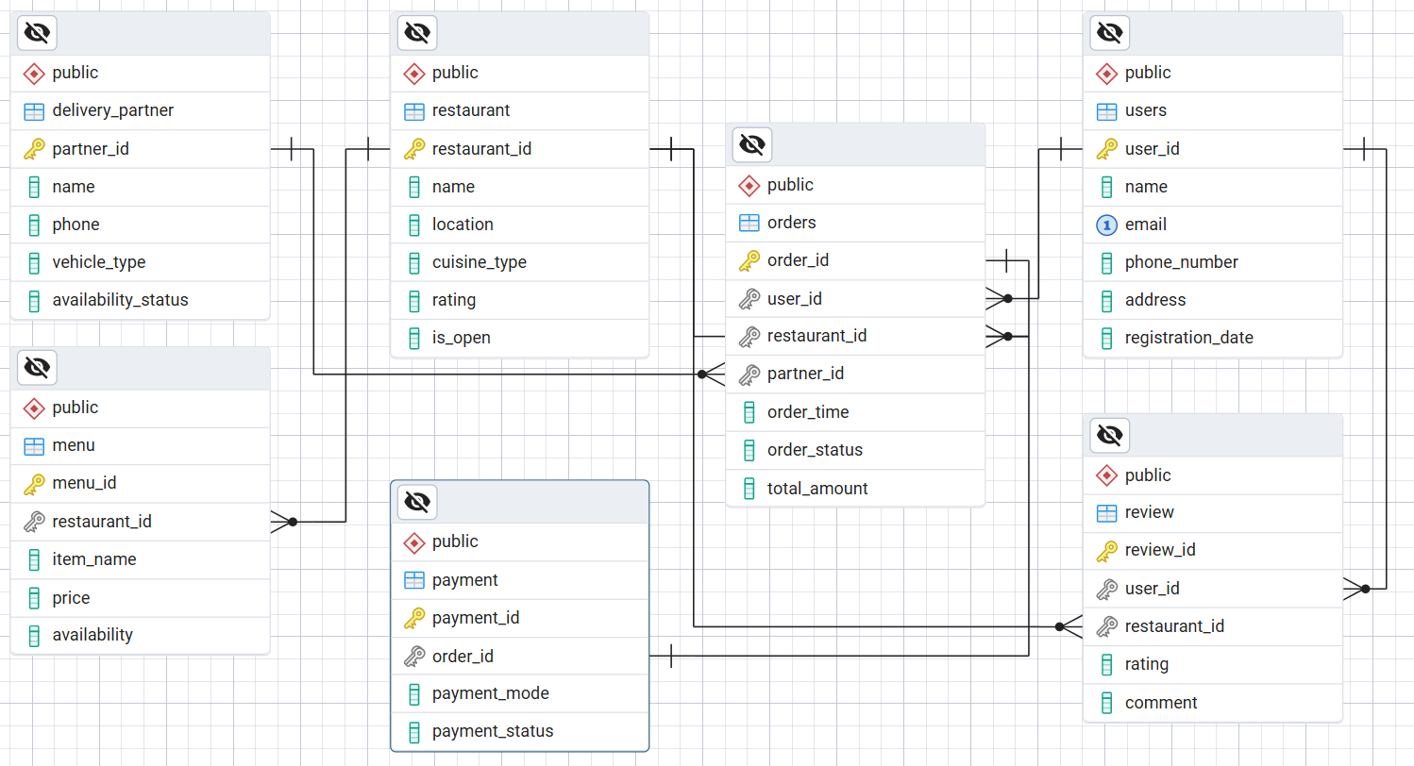

Presentation of Findings

Swiggy’s success lies in its robust schema design that efficiently connects users, restaurants, menu, orders, delivery partner, payments and review. The platform’s data architecture supports: - Fast order processing - Scalable delivery management - Personalized user experiences - Reliable real-time tracking. This modular schema supports Swiggy’s high-volume, real-time operations.

Conclusion
Swiggy is a prime example of how thoughtful product design and schema architecture can solve real-world problems at scale. By focusing on convenience, speed, and personalization, Swiggy has transformed food delivery in India. Its data-driven schema enables seamless coordination between multiple stakeholders, making it a leader in the hyperlocal delivery ecosystem.

